 | IQVIATM Work Instruction  New Marketing Authorization Applications
Document Number and Revision:
CS_WI_RA0300 Revision 2
Document Owner:  Anja De Pauw | Author(s):  Marine Lafargue, Tamara Lewicky

PURPOSE
To describe the procedure and responsibilities for the management of planning, preparation, publishing and submission of new Marketing Authorization Applications (MAAs) by Regulatory Affairs and Drug Development Solutions (RADDS).

SCOPE
This work instruction (WI) applies to all IQVIA RADDS staff performing activities on Pre- Registration/Registration projects.

ROLES AND RESPONSIBILITIES
The following roles perform tasks described within this WI:

Role | Sections
Regulatory Lead (RL) | 6.1, 6.2, 6.3, 6.4, 6.6, 6.7, 6.8, 6.9,  6.11
Project Team Member (PTM) | 6.5, 6.6, 6.7, 6.10, 6.11
Regulatory Writer (RW) | 6.2, 6.3, 6.4, 6.6, 6.7, 6.8, 6.9, 6.11
Regulatory Quality Control Reviewer (RQC) | 6.3, 6.4, 6.5, 6.8, 6.9, 6.10, 6.11
Regulatory Publisher (RP) | 6.5, 6.10

An individual can have more than one role. A RL can perform the role of RQC. However, a RW cannot review work that he/she has prepared and therefore cannot be both RW and RQC for the same deliverable.

DEFINITIONS
Not Applicable

MATERIAL AND EQUIPMENT
Not Applicable

PROCEDURE
After the Submission Plan is defined, the process can differ slightly if it is a new MAA submission with a full dossier or a new MAA submission with a reference dossier for remediation and/or conversion. To illustrate this, the procedure has been split into 2 scenarios:
- Scenario A: new MAA submission with a full dossier (starting section 6.2),
- Scenario B: new MAA submission with reference dossier (starting – section 6.7).

Page 1 of 15
Copyright © 2020, 2022. IQVIA. All rights reserved. The contents of this document are confidential and proprietary to IQVIA Holdings Inc. and its subsidiaries. Unauthorized use, disclosure or reproduction is strictly prohibited.

  - Define Submission Plan

No: | Who: | Step: | When:
6.1.1 | RL | - Refers to CS_WI_RA0273 (Global Regulatory Affairs - Project Management of GRA Projects) for the project management of all RADDS projects.  - If a new project, prepares a Project Instruction (PI) using CS_TP_PL0073 Project Instruction Template.  - If it is an existing project (e.g. project extension, European mutual recognition procedure to add new countries after the national procedure, Repeat Use Procedure), enters the submission details in the existing project management file (example: regulatory Excel tracker, SharePoint, or any other applicable format or Tracking Tool), completing all relevant fields and updates the PI to cover the extended scope of work. | At start of project
6.1.2 | RL | - Discusses submission plan format with the customer, i.e. MS Project, Excel or PowerPoint presentation, which should include relevant data such as:  - relevant Health Authority (HA) and submission timeline information,  - required pre-submissions or other steps prior to MAA submission  - roles and responsibilities,  - the list of deliverables,  - key timelines and prioritization for tasks and milestones,  - comments/ issues impacting deliverables,  - identification of risks,  - severity and mitigation/ action plan,  - dossier quality management plan,  - other information/documents required by the customer.  - Confirms with the customer the format of the final deliverable,  e.g. only electronic Word documents, final-for-submission package (i.e., Electronic Common Technical Document (e- CTD), Non-eCTD Electronic Submissions (NeeS), paper, other) as per the target country’s submission requirements.  - Creates and provides the submission plan to the customer for review.  Note: As the submission plan is a dynamic document, subsequent updates may occur during the project to adjust deliverables and timelines.  - Discusses and agrees both the initial plan and any subsequent adjustments with the customer via meeting minutes or email  and, if applicable, provides an updated version of the plan to the customer. | At submission plan execution
6.1.3 | RL | - Distributes the agreed submission plan to the team members to notify key internal partners and required cross-functional subject matter experts (SMEs) for roles and responsibilities.  - Sets up a meeting with all the internal stakeholders, e.g. Writers and Publishing to discuss this submission plan and agree on timings and responsibilities. | After agreement of the submission plan

Scenario A: New MAA with Full Dossier

  - Filing Strategy, Regulatory Requirements, Gap Analysis Review of existing data and Submission Plan

No: | Who: | Step: | When:
6.2.1 | RL | - If applicable and required by customer, determines the filing strategy.  - Collects the relevant regulatory intelligence.  - Applies regulatory requirements and previous experience as appropriate.  - Requests submission source documents from customer including the customer’s templates.  - Follows up the receipt of source documents/information with the customer and alerts the customer of delays that may impact IQVIA deliverables.  - Identifies potential gaps or missing documents and confirms country specific pre-requisites (e.g. legalization, payment, mockups).  - Requests ad hoc support from the following subject matter experts if required: CMC Expert, Pre-Clinical Expert, MD Expert in Drug Development, Statistics Expert. | Before preparation of the MAA package
6.2.2 | RW | In parallel:  With cross-functional SMEs:  - Performs a Gap Analysis and internal review of customer- authored document(s) which can include, but is not limited to: CMC data, validation reports, certificates of analysis, nonclinical study reports, Clinical study reports (CSRs), Pediatric investigation plan (PIP) and any other relevant documents from customer.  - Performs Literature Research if applicable (CMC, non- clinical and clinical).  - Shares the outcome of the Gap Analysis with the PL.
6.2.3 | RL | - Provides final Gap Analysis results to the customer  - Upon customer review of final Gap Analysis, follow up meeting can be organized to discuss the identified gaps with recommendations for addressing . | Before preparation of the MAA package

  - Pre-Submission Meeting

No: | Who: | Step: | When:
6.3.1 | RL | Based on the output of the Gap Analysis and Filing strategy:  - If needed, identifies and coordinates between the IQVIA project team and customer preparation of the pre-submission meeting with the HA. | Before preparation of the MAA package
6.3.2 | RW | - Develops with appointed SMEs a pre-submission package, using applicable template.

No: | Who: | Step: | When:
6.3.3 | RQC | - Performs quality control (QC) of the pre-submission package as per CS_WI_RA032 Global Regulatory Affairs - Preparation, Quality Control and Provision of Regulatory Affairs Deliverables.  - Records the QC of the pre-submission package using template CS_TP_RA0295 Global Regulatory Affairs - Quality Control  (QC) Checklist or other checklist as per project-specific needs and/or as agreed with the customer.
6.3.4 | RL | - Prepares for meeting internally and with customer.  - Submits meeting request to the HA, schedules meeting and coordinates all logistics.  - Conducts meeting with the HA (teleconference or face to face) as per CS_WI_RA010 Global Regulatory Affairs - Conducting and Documenting Communications with Regulatory Authorities.  - If required, performs post-meeting requirements fulfillment, risks reassessment and modifications/updates to initial submission plan per meeting outcome. Submits meeting notes to the HA (if applicable), customer and internal stakeholders.  - In case of any subsequent modifications/updates to initial submission plan, revised document must be distributed to the team members and the customer.  - Coordinates and leads a collaborative meeting to discuss HA responses to determine impact to MAA submission.

  - Dossier Preparation and Review

No: | Who: | Step: | When:
6.4.1 | RW | Dossier Preparation  - If applicable (eCTD format), the finalized and QC’d documents (e.g. Good Manufacturing Practices (GMP) certificates, Manufacturing Licenses, Technical reports, CSRs) can be send on a rolling basis to Publishing via shared mailbox (raddspubstaffing@iqvia.com) to make them submission ready (e.g. bookmarking links).  - Works in close collaboration with the cross-functional SMEs and follows CS_WI_RA032 Global Regulatory Affairs Preparation, Quality Control and Provision of Regulatory Affairs Deliverables to prepare the MAA package files based on the corresponding country’s regulatory requirements (generally CTD), scope of work and using the source documents/ information provided by the customer.  - If translations are required (e.g., Cover letter, Delegation Letter, Manufacturing Licenses), the customer can use their own translating agency but if in scope for IQVIA refer to CS_WI_RA0262 Global Regulatory Affairs - Translation of documents. | During the preparation of the MAA

No: | Who: | Step: | When:
6.4.2 | RQC | Quality Review of Dossier  - Performs a QC review of the MAA package files as per CS_WI_RA032 Global Regulatory Affairs – Preparation, Quality Control and Provision of Regulatory Affairs Deliverables.  - Records the QC of the MAA package using template CS_TP_RA0295 Global Regulatory Affairs - Quality Control (QC) Checklist or other checklist as per project-specific needs and/ or as agreed with the customer. | After preparation of each individual document
6.4.3 | RW | - Implements the QC comments received from the RQC.  - Requests input from the SMEs, as applicable. | After completion of the internal QC by RQC
6.4.4 | RL | - Sends final reviewed internal documents to customer for their review.  - Prepares and provides to the customer, for most complex files (e.g., Non-clinical and Clinical summaries, Module 3) two drafts and a final version for each deliverable, as per Work Order and agreed PI. The requirement for additional drafts should be discussed if required and a new budget estimate agreed.  - Requests customer to provide consolidated comments for each draft, with updates/ changes tracked using the track changes tool.  - Meets the timelines that were agreed with the customer, otherwise proactively informs the customer of any potential and actual delays.  - If necessary, holds internal meetings or meetings with the customer to manage the overall comments on the documents.
6.4.5 | RW | - Addresses the comments received from the customer as applicable.  - Requests input from the SMEs if required. | After customer returned their feedback
6.4.6 | RQC | - Performs a QC review of the addressed comments in accordance with CS_WI_RA032 Global Regulatory Affairs - Preparation, Quality Control and Provision of Regulatory Affairs Deliverables.  - Records the QC of the addressed comments using CS_TP_RA0295 Global Regulatory Affairs - Quality Control (QC) Checklist or other checklist as per project specific needs and/or as agreed with the customer. | After customer comments have been implemented
6.4.7 | RL or designee | - At final draft, delivers MAA package files to the customer for review and approval. | After QC changes have been implemented
6.4.8 | RW | - If remaining comments from customer on final draft of the MAA package files, addresses the last comments received as per  6.4.5 step. | After customer returned their feedback
6.4.9 | RQC | - Performs a QC review of the addressed comments on final draft and records the QC in QC checklist as per 6.4.6 step. | After customer returned their  feedback
6.4.10 | RL or designee | - Consolidates final Document Plan as per eCTD Meta Data Property if submission is done through eCTD. | After QC changes have been implemented

  - Publishing

No: | Who: | Step: | When:
6.5.1 | PTM | - Send filled-in Publishing - Standard Publishing Request Template CS_TP_RA0282 to the RADDS Pub Staffing distribution list (raddspubstaffing@iqvia.com). Provides complete package of final source files and an ordered inventory of documents via file share and/or RegDocs 365/SharePoint, or  another secured manner as applicable and as agreed in the PI. | When an MAA document is ready for publishing, if publishing is performed by IQVIA
6.5.2 | RP | - Performs publishing activities as per CS_WI_RA0292 Publishing – Producing Clinical and Submission Publishing Deliverables.  - Refers to CS_WI_RA014 (Publishing - Assembly of Regulatory Documents).  - Delivers final project deliverable to Requestor as agreed for the project, and according to the agreed submission plan.
6.5.3 | RQC | - Performs a last QC of the whole MAA package in its entirety before giving green light for submission.  - Notifies the RP if any changes need to be made. | When an MAA document is ready for publishing, if publishing is performed by  IQVIA
6.5.4 | RP | - Reviews any changes requested by the RQC and makes the necessary changes to the published output files.  - Delivers final project deliverable to customer, Requestor or HA as agreed for the project, and according to the agreed submission plan.  - QC/review steps are repeated, as needed until the MAA package is approved in its entirety for release by requestor and/or customer as applicable. | When an MAA document is ready for publishing, if publishing is performed by IQVIA

  - Dossier Submission and Post-Submission Follow-up

No: | Who: | Step: | When:
6.6.1 | PTM | Dossier Submission  - Prepares the final-for-submission-ready package.  - If not performed by RP or customer directly as agreed, submits the MAA submission ready package through the appropriate submission pathway (e.g., CESP, EMA gateway, MHRA portal or any other submission portal, or other formats and routes depending on the submission country).  - Provides the proof of submission to the customer and files it in the project folder or drive as applicable.  - Files deliverables as agreed with the customer and indicated in the submission plan, e.g. in IQVIA’s project folder or drive as applicable, and/or SharePoint and/or the customer’s electronic document management systems. | After MAA package internal and (if applicable) external approval

No: | Who: | Step: | When:
6.6.2 | PTM | Post-submission follow-up  - Follows up with the HA on the status of the submitted MAA (update on validation status, if applicable) in accordance with CS_WI_RA010 Global Regulatory Affairs - Conducting and Documenting Communications with Regulatory Authorities.  - Provides support with preparation of responses to validation questions/issues or responses to questions/additional  information requested by the HA. | After MAA submission, if required by the customer
6.6.3 | PTM | Prepare Response to HA (if applicable)  - Stores all communication with HA related to validation queries or request for further information in IQVIA’s folder or drive and/or SharePoint and/or the customer’s electronic document management systems.  - Searches relevant experience from previous responses. | Upon receipt of validation issues or request for further information from the HA, if required by the customer
 | RL | - Confirms response strategy with the customer.
 | RW | - Prepares Response to Questions requested by HA, using applicable Template Document (e.g., Agency or customer template).  - Drafts, revises, and/or updates response sections.  - Requests input from SMEs, as applicable.
6.6.4 | RL, RW  and RQC | - Performs same steps as for initial MAA package (6.4.2 to 6.4.10) for writing and QC covering both internal and external reviews with customer.  - QC review steps of responses are repeated as needed until the responses are approved for release by requestor and/or customer as applicable.
6.6.5 | RL | MAA Approval  - Informs the customer and applicable stakeholders of the approval within 2 working days after receipt of approval (or as indicated in the agreed PI) and includes the original language Approval Letters or any other proof of approval.  - Archives the Approval Letters in Project Drive or project folder or as mentioned in the PI.  - For European Procedures: Organizes post approval national steps as per requested/mandatory established deadlines (e.g., National Translations for Product Information).  - If translations are required, the customer can use their own translating agency but if in scope for IQVIA refer to CS_WI_RA0262 Global Regulatory Affairs - Translation of documents.  - If applicable, prepares and submits a closing eCTD sequence within 15 days of approval (e.g., Centralized procedure) if required | After MAA Approval
6.6.6 | RL | Archive  - Archives and returns documentation as outlined in CS_WI_RA0273 Global Regulatory Affairs - Project  Management of GRA Projects. | After project completion or as agreed with the customer

Scenario B: New MAA with Reference Dossier

  - Filing Strategy, Regulatory Requirements, Gap Analysis Review of existing data and Submission Plan

No: | Who: | Step: | When:
6.7.1 | RL | - Determines markets impacted  - Determines filing strategy  - Collects relevant regulatory intelligence  - Applies regulatory requirements and previous experience as appropriate  - Requests submission source documents from customer including the customer’s templates. | Before preparation of the MAA package
6.7.2 | PTM | Dossier Remediation  - Defines Submission Plan for Remediation.  - Assesses current dossier for accuracy, if applicable and agreed with the customer.  - Collects required data and if required performs additional Literature Research.  - Fills in gaps or confirms pre-requisites (e.g. legalization, payment, mockups).  - Collects country-specific documents (e.g. mockups, legal documents).
6.7.3 | RW | In parallel:  - Contacts cross-functional SMEs, if required.  - Conducts Gap Analysis of existing dossier and internal review of customer-authored document(s) (can include but not limited to: Investigational brochure (IB), PIP, CSRs and any other relevant documents from customer).
6.7.4 | RL | - Reports the identified gaps with recommendations for addressing and provides Gap Analysis results to customer.  - Follows up on the receipt of source documents/information from the customer and alerts the customer of delays that may impact IQVIA deliverables.
6.7.5 | PTM | Dossier conversion  - Determines dossier conversion requirements  - Defines Dossier conversion plan  - Determines if update to format is required: CTD, eCTD, or any other required local format.

  - Pre-Submission Meeting

No: | Who: | Step: | When:
6.8.1 | RL | Based on the output of the Gap Analysis and Filing strategy:  - If needed, identifies and coordinates between IQVIA project team and customer the preparation of pre-submission meeting with HA. | Before preparation of the MAA package
6.8.2 | RW | - Develops meeting pre-submission package, using the appropriate template if applicable.

No: | Who: | Step: | When:
6.8.3 | RQC | - QC pre-submission package as per CS_WI_RA032 (Global Regulatory Affairs - Preparation, Quality Control and Provision of Regulatory Affairs Deliverables).  - Records the QC of the pre-submission package as per checklist template CS_TP_RA0295 Global Regulatory Affairs -  Quality Control (QC) Checklist or other checklist as per project specific needs and/or as agreed with the customer.
6.8.4 | RL | - Prepares for meeting internally and with customer  - Submits meeting request to HA, schedules meeting and coordinates all logistics.  - Conducts meeting with HA (teleconference or face to face) as per CS_WI_RA010 Global Regulatory Affairs - Conducting and Documenting Communications with Regulatory Authorities.  - If required, performs post-meeting requirements fulfillment, risks reassessment and modification/updates to initial submission plan per meeting outcome.  - In case of any subsequent modifications/updates to initial submission plan, revised document must be distributed to the team members and the customer.  - Submits meeting notes to HA (if applicable), customer and internal stakeholders.  - Coordinates and leads a collaborative meeting to discuss HA responses to determine impact to MAA submission

  - Dossier Preparation and Review

No: | Who: | Step: | When:
6.9.1 | RW | Dossier Preparation  - If applicable (eCTD format), the finalized and QC’d documents (e.g. Good Manufacturing Practices (GMP) certificates, Manufacturing Licenses, Technical reports, CSRs) can be send on a rolling basis to Publishing via shared mailbox (raddspubstaffing@iqvia.com) to make them submission ready (e.g. bookmarking links). Authors additional submission component(s) in close collaboration with the cross-functional SMEs (when required) and follows CS_WI_RA032 (Global Regulatory Affairs - Preparation, Quality Control and Provision of Regulatory Affairs Deliverables) to prepare the MAA package files based on the corresponding country’s regulatory requirements (generally CTD) and using the source documents/ information provided by the customer.  - If translations are required (e.g., Cover letter, Delegation Letter, Manufacturing Licenses), the Customer can use their own translating agency but if in scope for IQVIA refers to  CS_WI_RA0262 (Global Regulatory Affairs - Translation of documents) | During the preparation of the MAA

No: | Who: | Step: | When:
6.9.2 | RQC | Quality Review of Dossier  - Performs a QC review of the MAA package files as per CS_WI_RA032 (Global Regulatory Affairs - Preparation, Quality Control and Provision of Regulatory Affairs Deliverables).  - Records the QC of the MAA package using CS_TP_RA0295 Global Regulatory Affairs - Quality Control (QC) Checklist or other checklist as per project specific needs and/ or as agreed with the customer. | After preparation of each individual document
6.9.3 | RW | - Implements the QC comments received from the RQC on the documents.  - Requests input from the SMEs if required. | After completion of the internal QC by RQC
6.9.4 | RL | - Sends final reviewed internal documents to customer for their review.  - Prepares and provides to the customer for most complex files (e.g., Non-clinical and Clinical summaries, Module 3) two drafts and a final version for each deliverable, as per Work Order and agreed PI. The requirement for additional drafts should be discussed if required and a new budget estimate agreed.  - Requests customer to provide consolidated comments for each draft, with updates/ changes tracked using track changes tool.  - Agrees with the customer timelines for the deliverable.  - Proactively informs the customer of any potential and actual delays (e.g. for review of each draft).  - Holds internal meetings or meetings with Customer as required to manage the overall comments on the documents.
6.9.5 | RW | - Implements the QC comments received from the customer on the documents.  - Requests input from the SMEs if required. | After customer returns their feedback
6.9.6 | RQC | - Performs a QC review of the addressed comments in accordance with CS_WI_RA032 Global Regulatory Affairs - Preparation, Quality Control and Provision of Regulatory Affairs Deliverables.  - Records the QC of the addressed comments using CS_TP_RA0295 Global Regulatory Affairs - Quality Control (QC) Checklist or other checklist as per project specific needs and/or as agreed with the customer. | After customer returned their feedback
6.9.7 | RL or designee | - Delivers the final draft MAA package files to the customer for review and approval. | After QC changes have been implemented
6.9.8 | RW | - Addresses remaining comments from customer on final draft of the MAA package files as per 6.9.5. | After customer returned their feedback
6.9.9 | RQC | - Performs a QC review of the addressed comments on final draft and records the QC in QC checklist as per 6.9.6. | After customer returned their  feedback
6.9.10 | RL or designee | - Consolidates final Document Plan as per eCTD Meta Data Property when submission is done through eCTD. | After QC changes have been implemented

  - Publishing

No: | Who: | Step: | When:
6.10.1 | PTM | Publishing  - Sends filled-in Publishing - Standard Publishing Request Template CS_TP_RA0282 to the RADDS Pub Staffing distribution list (raddspubstaffing@iqvia.com). Provides complete package of final source files and an ordered inventory of documents via file share and/or RegDocs 365/SharePoint, or another secured manner as applicable and as agreed in the PI. | When an MAA document is ready for publishing, if publishing is performed by IQVIA
6.10.2 | RP | - Refers to CS_WI_RA0292 (Publishing - Producing Clinical and Submission Publishing Deliverables) for publishing process.  - Refers to CS_WI_RA014 (Publishing - Assembly of Regulatory Documents).  - Delivers final project deliverable to Requestor as agreed for the project and according to the agreed submission plan.
6.10.3 | RQC | - Performs a last QC of the whole MAA before confirming approval for submission.  - Notifies the RP if any changes need to be made. | Before confirming approval for submission
6.10.4 | RP | - Reviews any changes requested by the RQC and makes the necessary changes to the published output files.  - Delivers final project deliverable to customer, Requestor or HA as agreed for the project, and according to the agreed submission plan.  - QC/review steps are repeated, as needed until the MAA package is approved for release. | When requested by RQC

  - Dossier Submission and Post-Submission Follow-up

No: | Who: | Step: | When:
6.11.1 | PTM | Dossier Submission  - Prepares the final-for-submission-ready package.  - If not performed by RP or customer directly as agreed, submits the MAA package trough appropriate submission pathway (i.e., CESP, EMA gateway, MHRA portal, or any other submission portal, or other formats and routes depending on the submission country, accordingly).  - Provides the proof of submission to customer and files it in the project folder or drive as applicable.  - Files deliverables as agreed with the customer, e.g. in IQVIA’s project folder or drive as applicable, and/or SharePoint and/or the customer’s electronic document management systems as agreed and indicated in the PI. | After MAA package internal and (if applicable) external approval
6.11.2 | PTM | Post-submission follow-up  - Follows up with the HA on the status of the submitted MAA (Update on validation status, if applicable).  - Refers to CS_WI_RA010 (Global Regulatory Affairs - Conducting and Documenting Communications with Regulatory Authorities). | After MAA submission, if required by the customer

No: | Who: | Step: | When:
 |  | - Provides support with preparation of responses to validation issue or responses to questions/additional information requested by the HA.
6.11.3 | PTM | Prepare Response to HA (if applicable)  - Stores every communication with HA related to Validation queries or request for further information in IQVIA’s folder or drive and/or SharePoint and/or the customer’s electronic document management systems.  - Searches relevant experience from previous responses. | Upon receipt of Validation issues or Request for further information from HA, if required by the customer
 | RL | - Confirms response strategy with customer.
 | RW | - Prepares Response to Questions requested by HA using applicable Template Document (e.g., Agency or customer template).  - Drafts, revises, and / or updates response sections.  - If required, input can be requested to the SMEs.
 | RL, RW  and RQC | - Perform same steps as for initial MAA package (6.9.2 to 6.9.10) for writing and QC covering both internal and external reviews with customer.  - Repeat QC review steps of responses as needed until the responses are approved for release by requestor and/or customer as applicable.
6.11.4 | RL | MAA Approval  - Informs the customer and applicable stakeholders of the approval within 2 working days after receipt of approval (or as indicated in the agreed PI) and includes the original language Approval Letters or any other proof of approval.  - Archives the Approval letters in Project Drive or project folder or as mentioned in the PI.  - For European Procedures: Organizes post approval national steps as per requested deadlines (e.g., National Translations for Product Information).  - If translations are required: Customer can use their own translating agency but if in scope for IQVIA please refer to CS_WI_RA0262 (Global Regulatory Affairs - Translation of documents).  - Prepares and submits a closing eCTD sequence within 15 days of approval (e.g., Centralized procedure), if applicable. | After MAA Approval
6.11.5 | RL | Archive  - Archives and returns documentation as outlined in CS_WI_RA0273 (Global Regulatory Affairs - Project Management of GRA Projects). | After project completion or as agreed with the customer

- SUPPORTING DOCUMENTATION
DOCUMENT NUMBER | TITLE
ESOP References
7.1 CS_WI_RA0273 | Global Regulatory Affairs Project Management of GRA Projects
7.2 CS_TP_PL0073 | Project Instruction Template
7.3 CS_WI_RA032 | Global Regulatory Affairs - Preparation, Quality Control and Provision of Regulatory Affairs Deliverables
7.4 CS_TP_RA0295 | Global Regulatory Affairs Quality Control (QC) Checklist
7.5 CS_WI_RA010 | Global Regulatory Affairs - Conducting and Documenting Communications with Regulatory Authorities
7.6 CS_WI_RA0262 | Global Regulatory Affairs - Translation of documents
7.7 CS_WI_RA0292 | Publishing - Producing Clinical and Submission Publishing Deliverables
7.8 CS_TP_RA0282 | Publishing – Standard Publishing Request Template
7.9 CS_WI_RA014 | Publishing - Assembly of Regulatory Documents

- SUPERSEDES

DOCUMENT NUMBER | TITLE | REVISION NUMBER
CS_WI_RA0300 | Global Regulatory Affairs – New Marketing Authorisation Applications | 1

- MODIFICATION FROM PREVIOUS REVISION

CHANGE | SECTION REFERENCE | JUSTIFICATION
This document has been converted from a GRA- document to a RADDS document | Document title, section 3 and 6 | Global Regulatory Affairs (GRA) was integrated with Regulatory Affairs and Drug Development Solutions (RADDS).
Titles of referenced documents CS_WI_RA0273 and CS_WI_RA0292 updated | Section 6 | These referenced documents have been renamed during their review.

- APPENDICES

  - Appendix A: Process Flow for New MAA with Full dossier (Scenario A)

  - Appendix B: Process Flow for New MAA with Reference dossier (Scenario B)

10.0 APPENDICES
  - 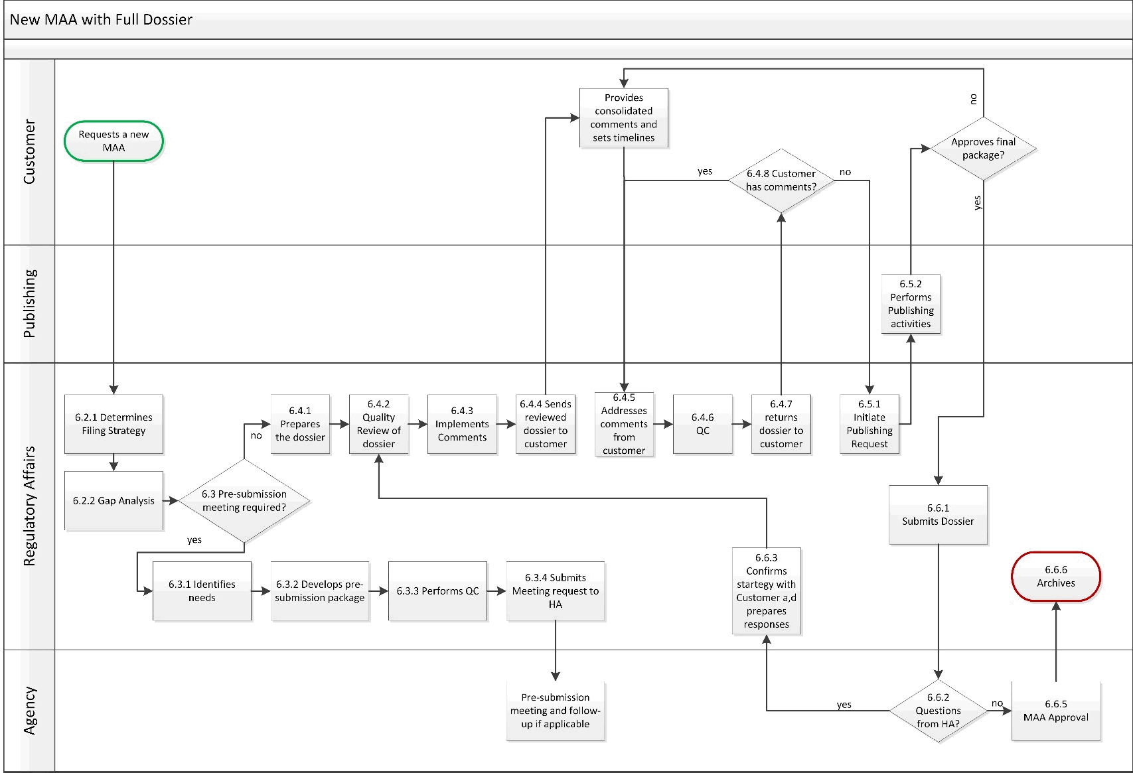AppendixA: Process Flow for New MAA with Full dossier (Scenario A)

  - Appendix B: Process Flow for New MAA with Reference dossier (Scenario B)
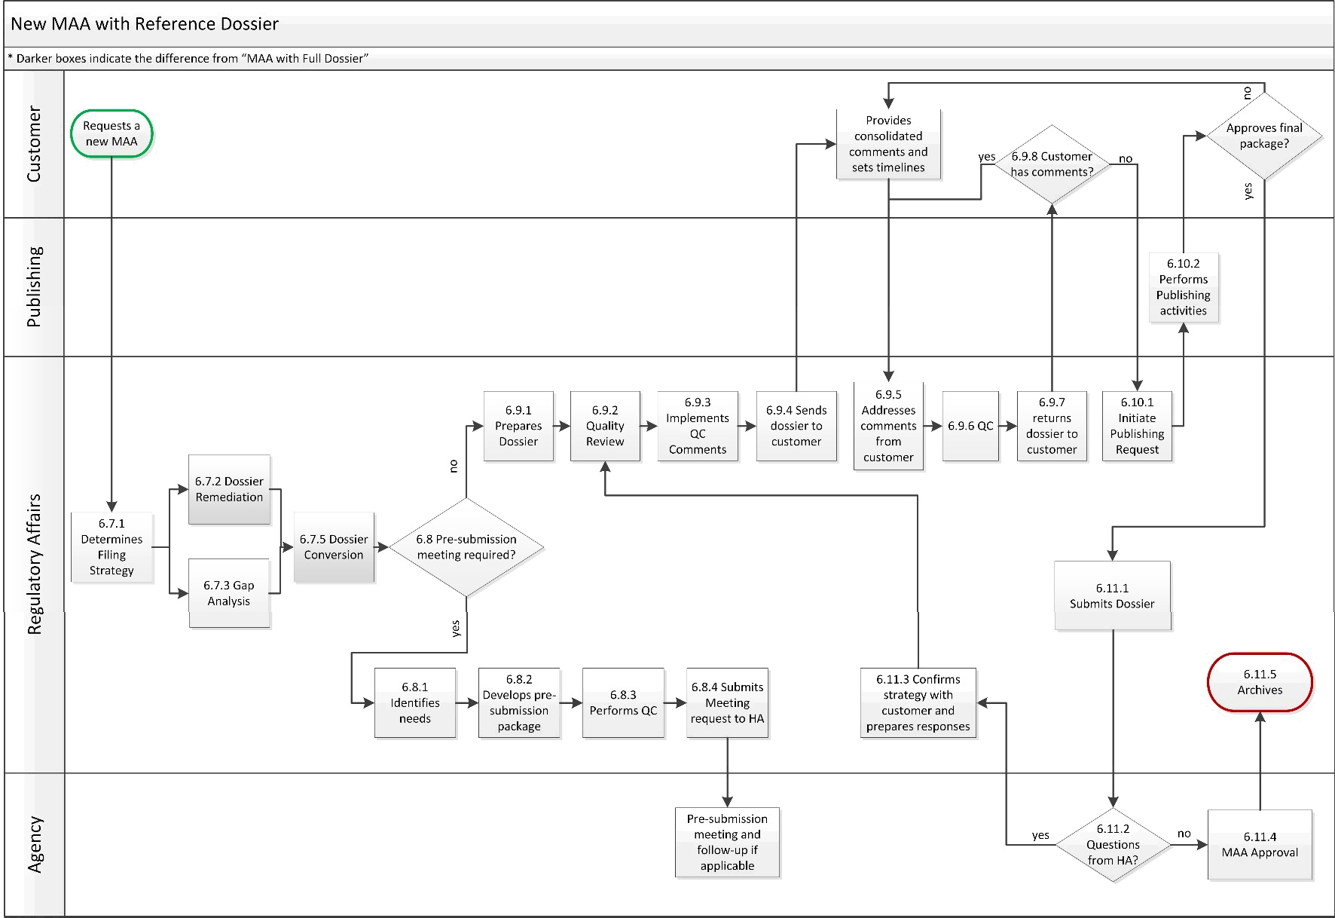

UserName: Schreiber, Cindy (q831321) Title:
Date: Tuesday, 08 November 2022, 02:27 PM Eastern Daylight Time Meaning: Signing this Document Indicates My Approval
================================================

UserName: Murphy, Kendra (q847871) Title:
Date: Tuesday, 08 November 2022, 09:37 PM Eastern Daylight Time Meaning: Signing this Document Indicates My Approval
================================================

UserName: Kemp, Jaco (q608126) Title:
Date: Wednesday, 09 November 2022, 02:16 AM Eastern Daylight Time Meaning: Signing this Document Indicates My Approval
================================================

UserName: Dobrychlop, Karolina (q1025820) Title:
Date: Wednesday, 09 November 2022, 03:02 AM Eastern Daylight Time Meaning: Signing this Document Indicates My Approval
================================================

UserName: Singh, Priti (q823374) Title:
Date: Wednesday, 09 November 2022, 03:53 AM Eastern Daylight Time Meaning: Signing this Document Indicates My Approval
================================================

UserName: NAJI, Kenza (u1090913) Title:
Date: Wednesday, 09 November 2022, 05:16 AM Eastern Daylight Time Meaning: Signing this Document Indicates My Approval
================================================

UserName: Pokharkar, Swapnil (q1019141) Title:
Date: Wednesday, 16 November 2022, 06:02 AM Eastern Daylight Time Meaning: Signing this Document Indicates My Approval
================================================

